Exploring Linux Cron Jobs

**Task 1: Cron Basics**
- It is a time based job scheduler in unix-like computer operating systems.
- Users who set up and maintain software environments use cron to schedule jobs to run periodically at fixed times,days,dates and intervals

crontab -l # command to show all the current jobs.
crontab -e # command to edit or add new jobs.

Cron job format

* * * * * path/scripts && ./create_file.sh

**Task 2: View Existing Cron Jobs**
- `crontab -l` - command to list the Cron jobs for the current user.

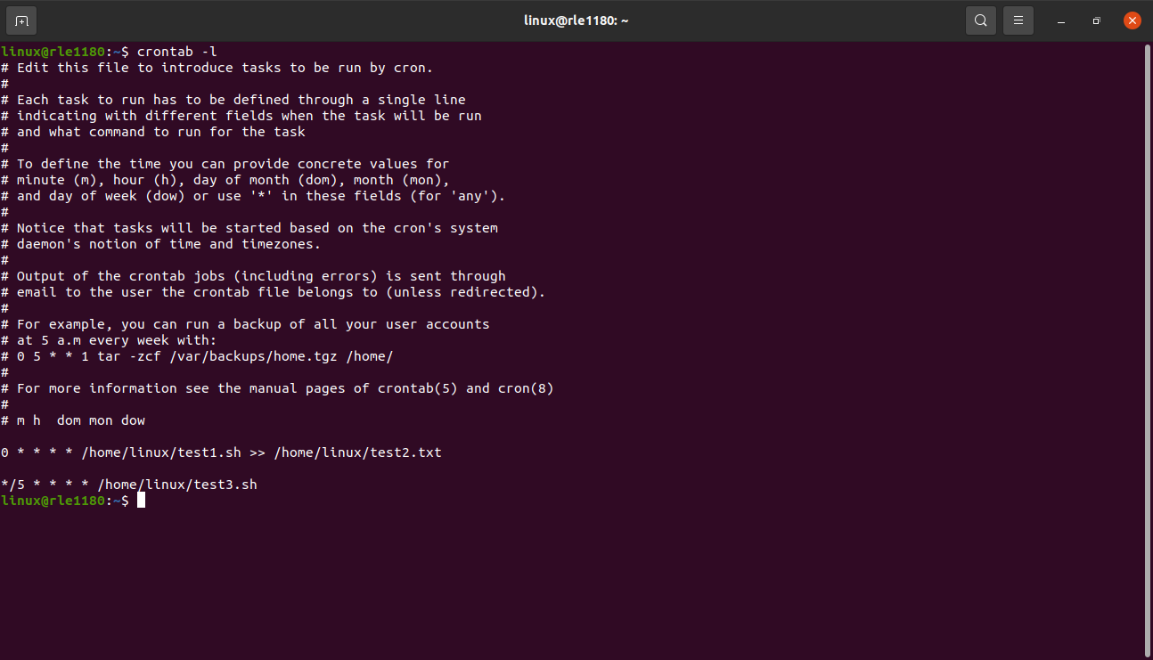
**Task 3: Create a Simple Cron Job**

- Create a simple text file containing a shell command or script (e.g., a "Hello, World!" script).
- nano test1.sh #it will create file
#!/bin/bash
echo “Hello,World!” # insert this into test1.sh
- change that test1.sh to executable format
chmod +x <file_name>
ex:- chmod +x test1.sh

- Use the `crontab -e` command to edit your user's Cron jobs.
- * * * * * /home/linux/test.sh >> /home/linux/test2.txt
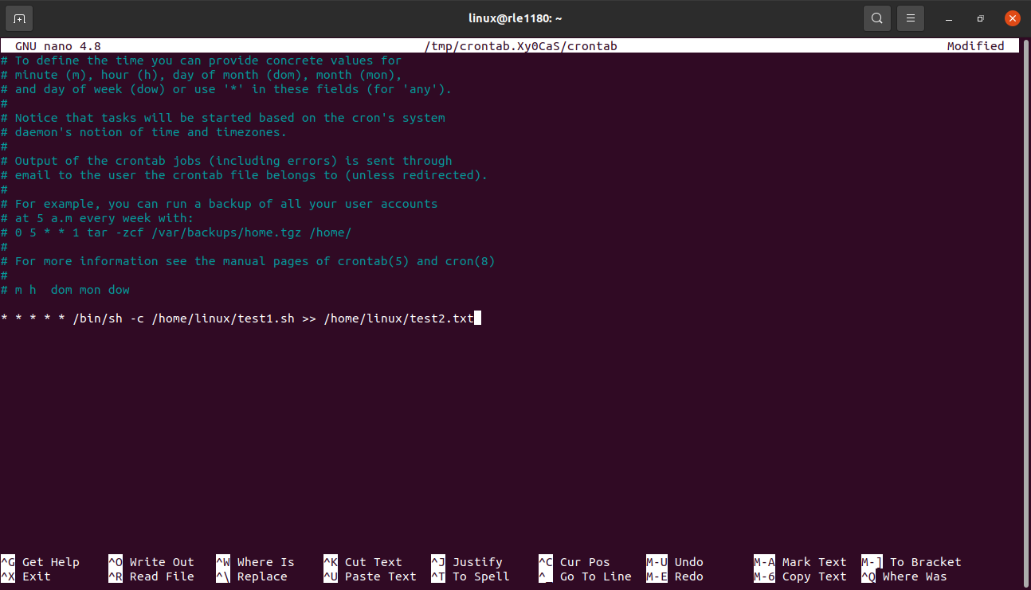
- Add an entry to execute your script every minute using Cron syntax.
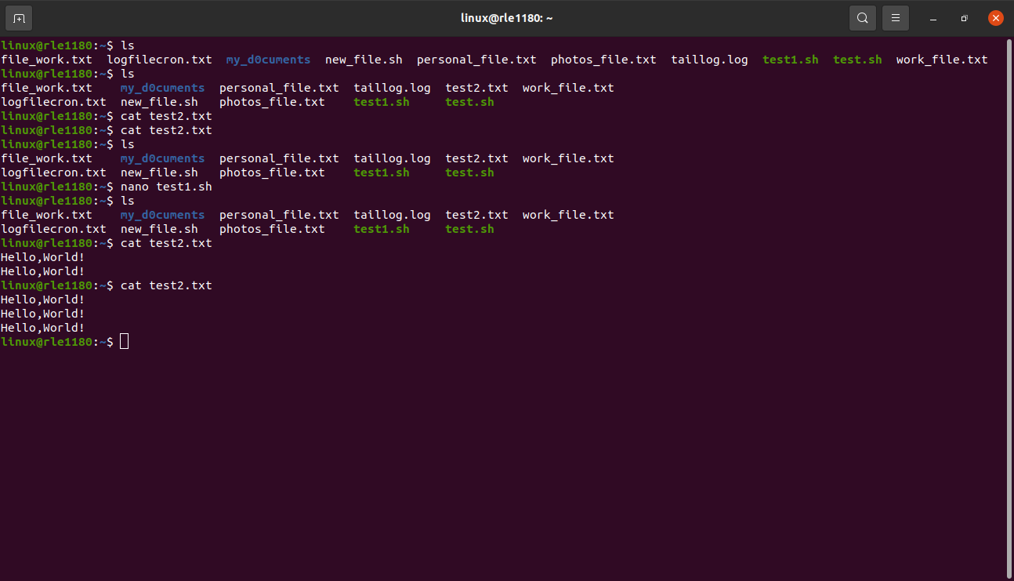
- Save and exit the editor.

**Task 4: Edit and Update Cron Jobs**

- Use the `crontab -e` command again to edit your user's Cron jobs.
- 0 * * * * /home/linux/test.sh >> /home/linux/test2.txt.

- Modify the Cron job from Task 3 to execute every hour instead of every minute.

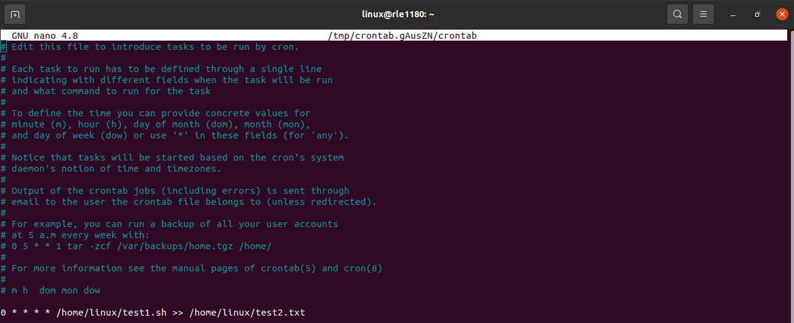
- Save and exit the editor.
**Task 5: Remove Cron Jobs**

- Use the `crontab -e` command to edit your user
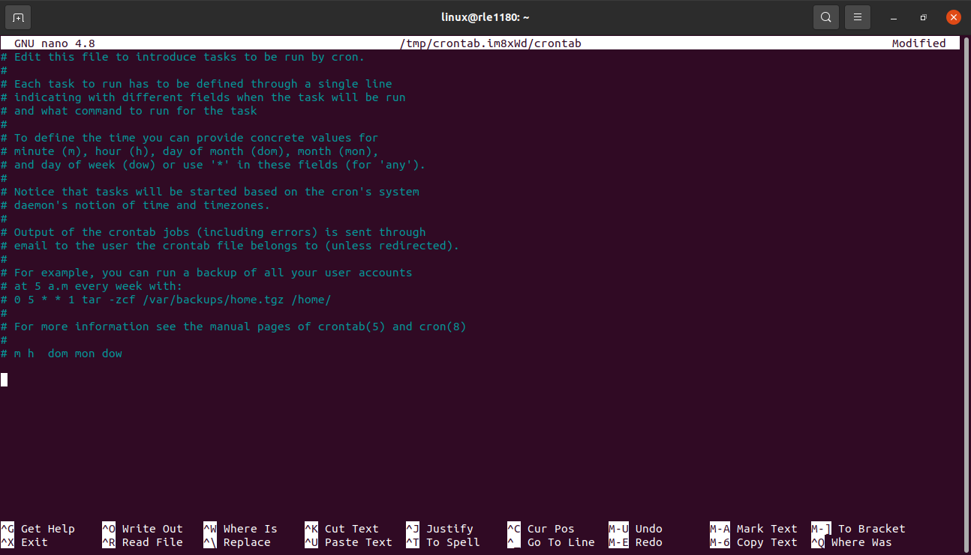

**Task 6: Monitor Cron Jobs**

- Use the `tail -f /var/log/syslog` command to monitor system logs.
- Create a shell script that has the command to check system logs.
nano test3.sh
- insert into test3.sh
#!/bin/bash
tail -f /var/log/syslog >> home/linux/logfile1.log
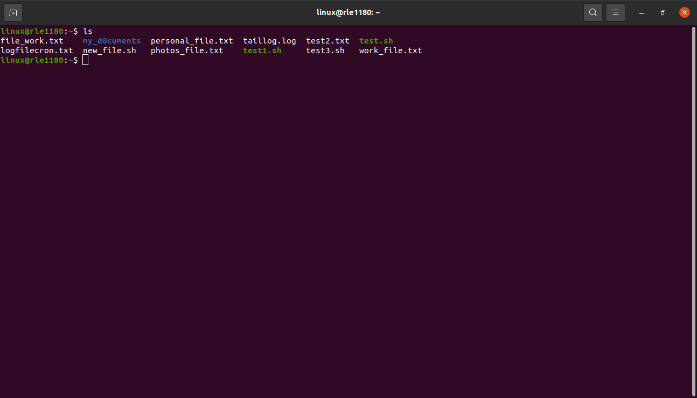
- Schedule a new Cron job to run a script that echoes a message to a log file every 5 minutes.

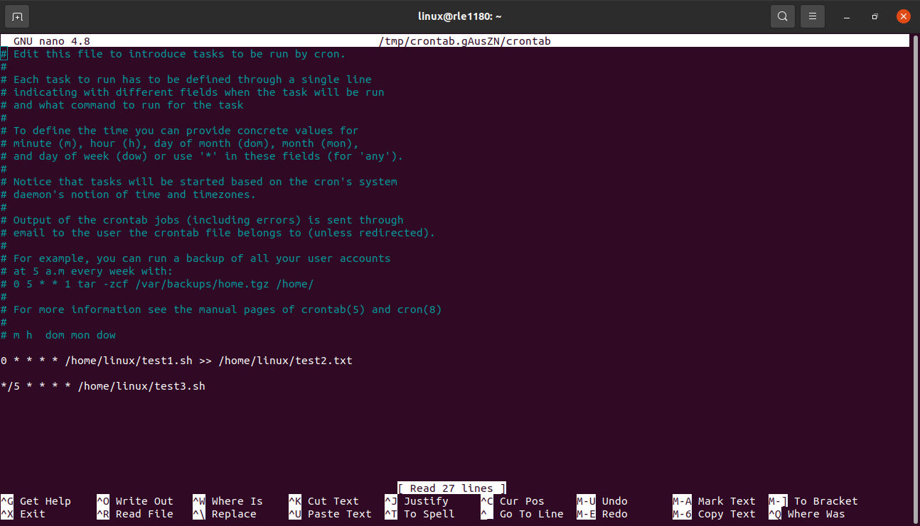

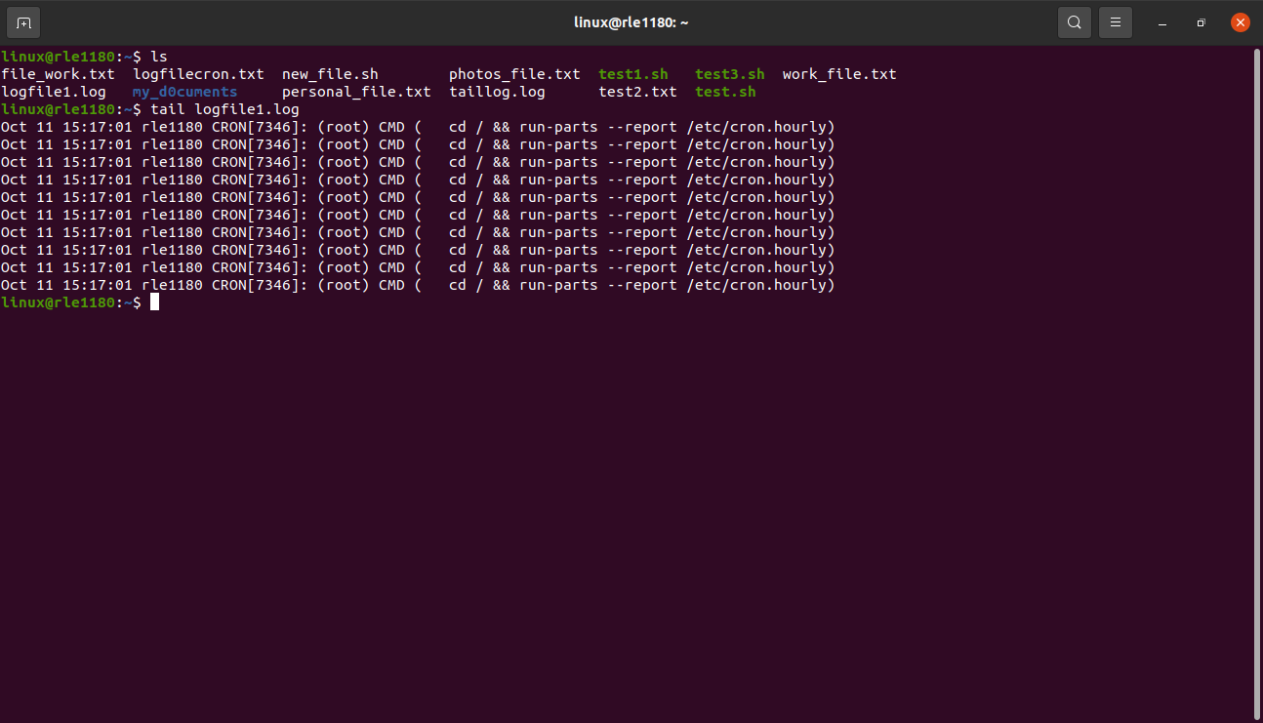
- Observe the log entries and confirm that your Cron job is running as

expected.

**Task 7: Explore Use Cases**
- Research and select a real-world use case for Cron jobs (e.g., automated backups, log rotation, data synchronization).
- Create a Cron job that simulates the selected use case.
- Go to the root directory.
- Cd /opt
- tar cvzf backup.tar.gz etc /var/log
- var_date = ‘date +%Y%m%d.%H%M’
- corntab -e
- create a directory
mkdir backups
- mv backup.tar.gz backups/
- nano sys_backup_daily.sh

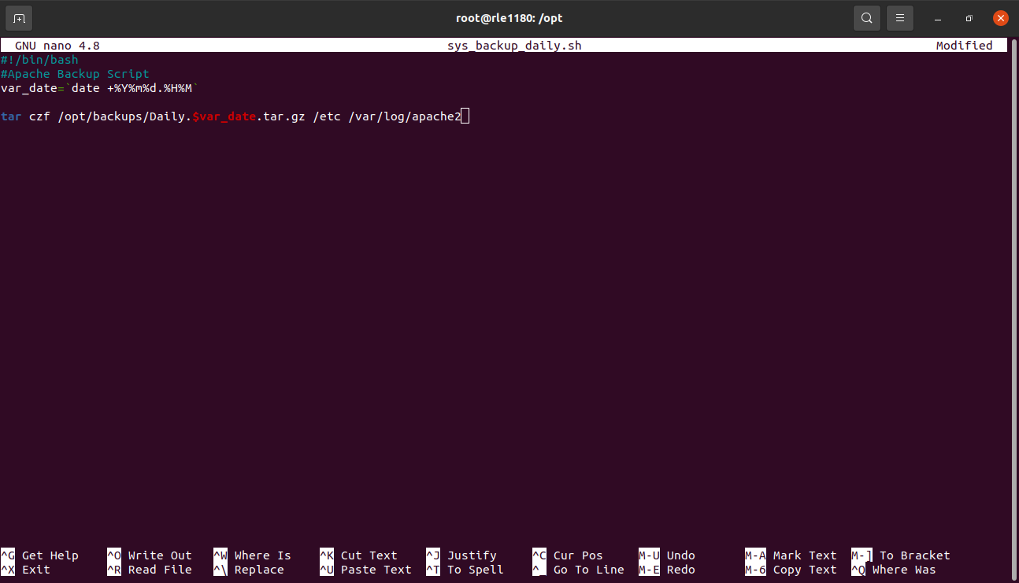
- ./sys_backup_daily.sh
- chomd +x sys_backup_daily.sh

- nano /etc/crontab
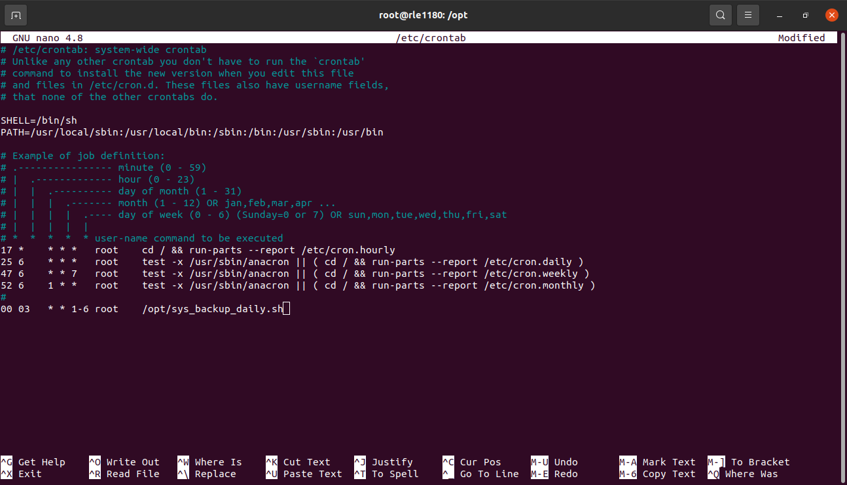
- cp sys_backup_daily.sh sys_backup_weekly.sh
- chmod +x sys_backup_weekly.sh
- nano sys_backup_weekly.sk
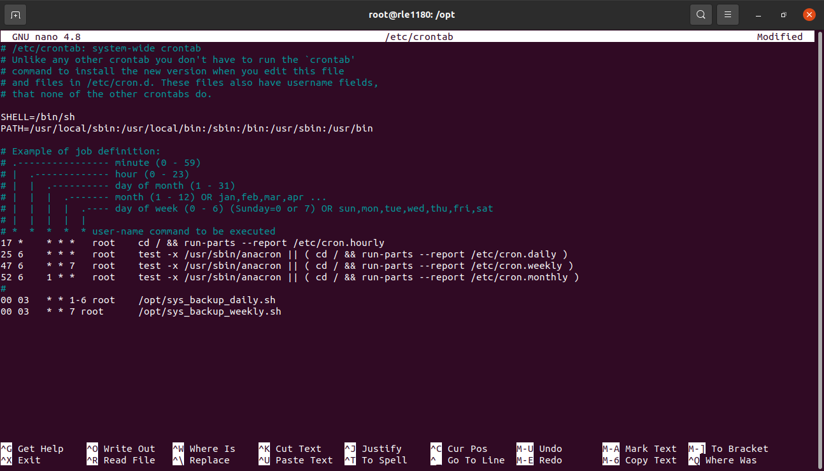
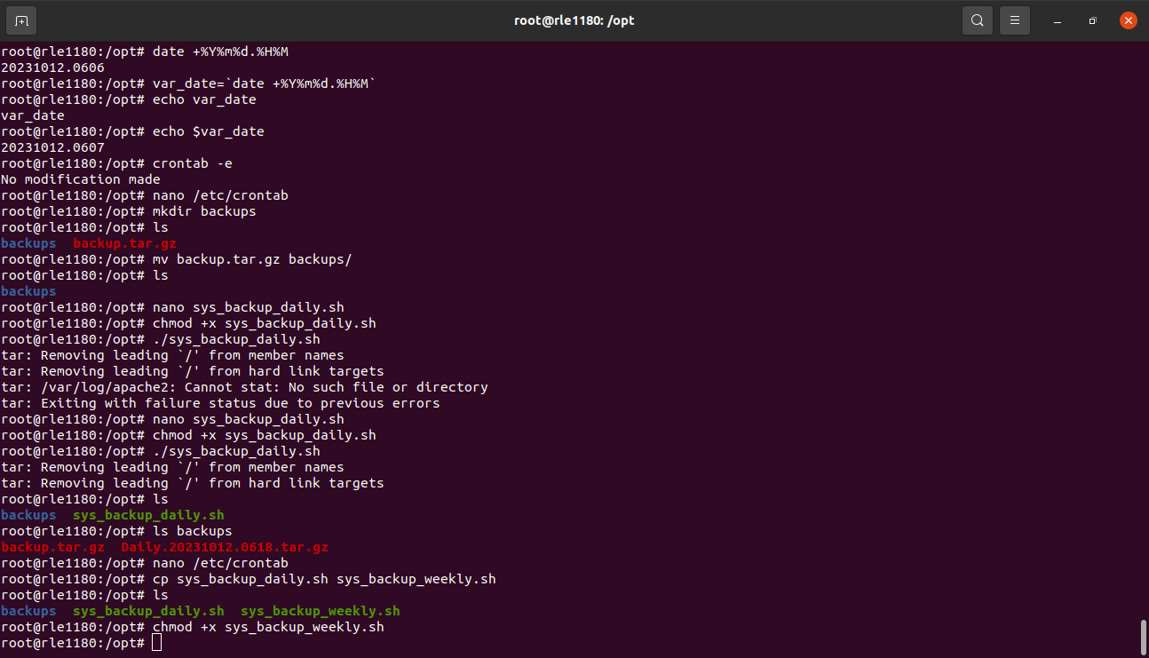
- Document the purpose, schedule, and behavior of your Cron job.
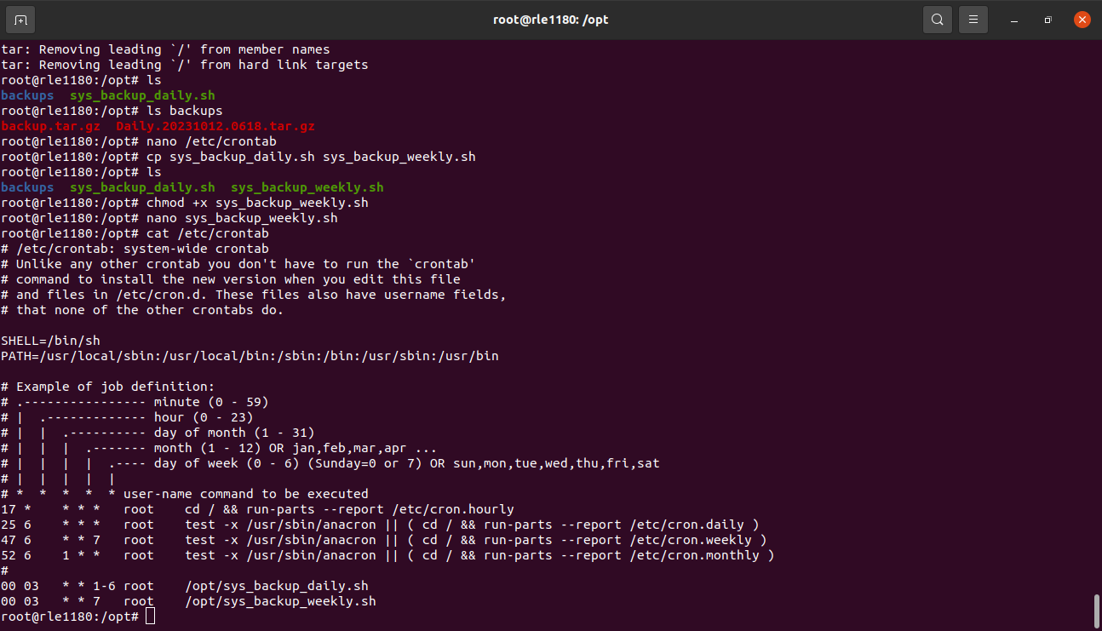
**Task 8: Troubleshooting**
- intentionally create a Cron job with a mistake, such as incorrect syntax or a non-existent script.
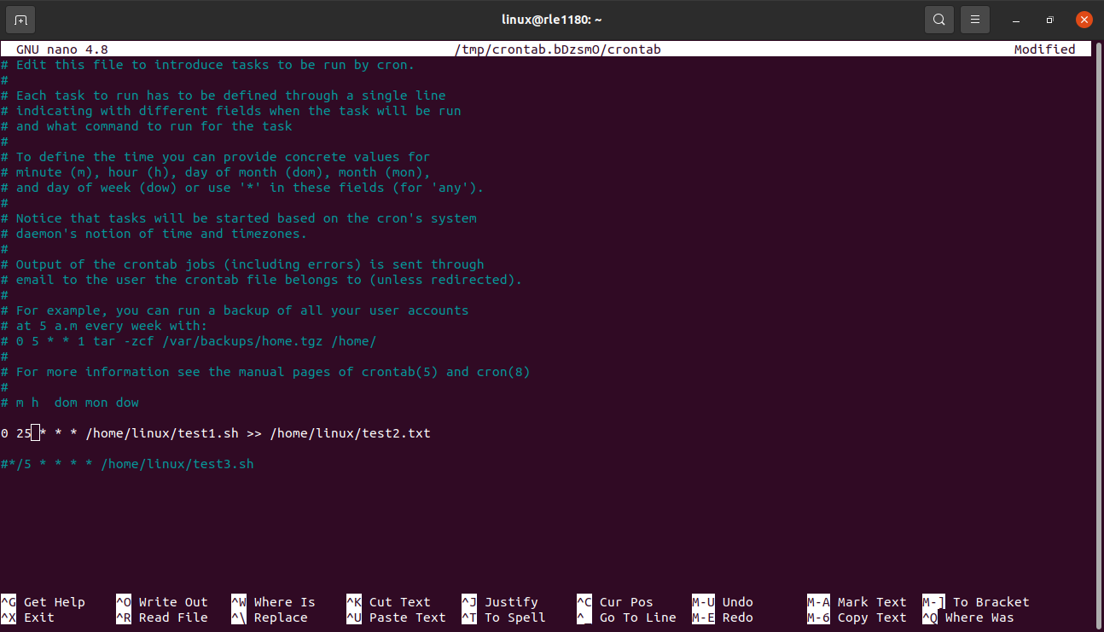

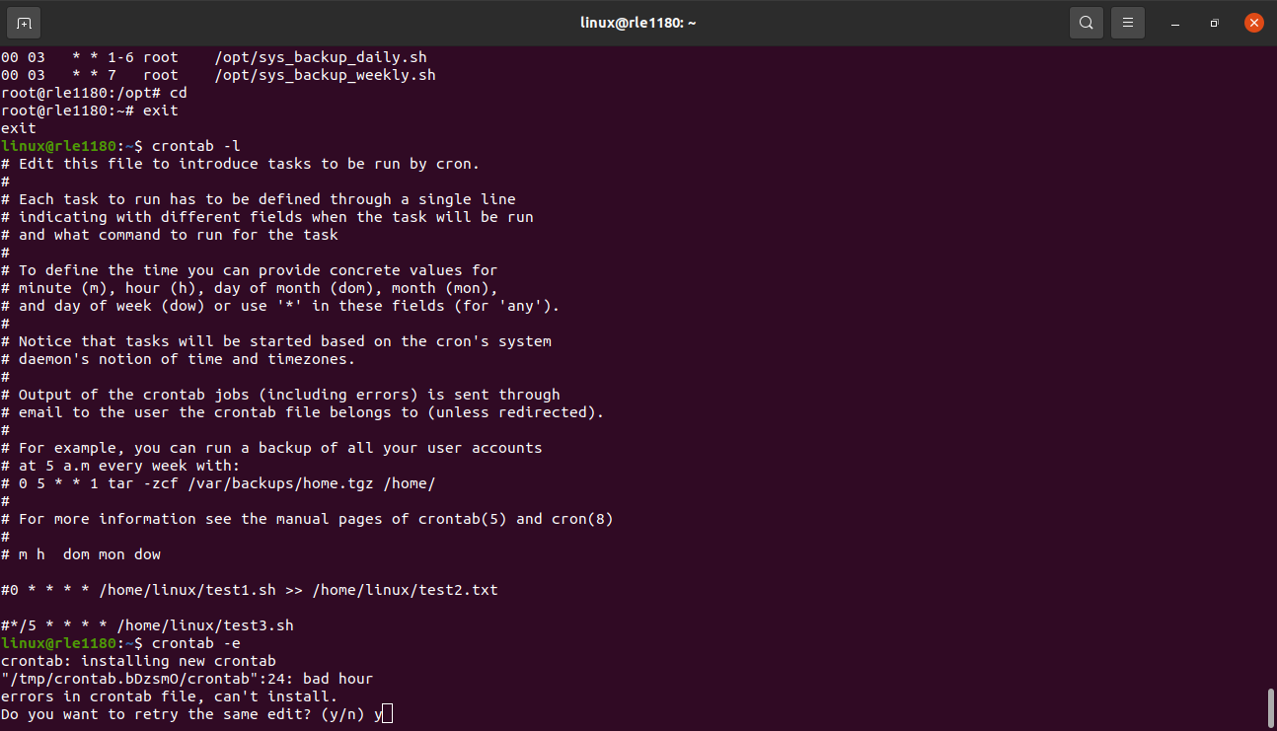

- If we enter the hour time more than 0-23 it will through an error of ‘bad hour’.
- Observe the error messages in system logs and troubleshoot the issue.

**Task 9: Cleanup**
- Use the `crontab -r` command to remove all of your user's Cron jobs.

- To remove a particular job
# crontab -e
- delete the particular job

- to delete all cron jobs
# crontab -r
- Delete any leftover scripts or files created during this assignment.

